**Output for engine light = Green**

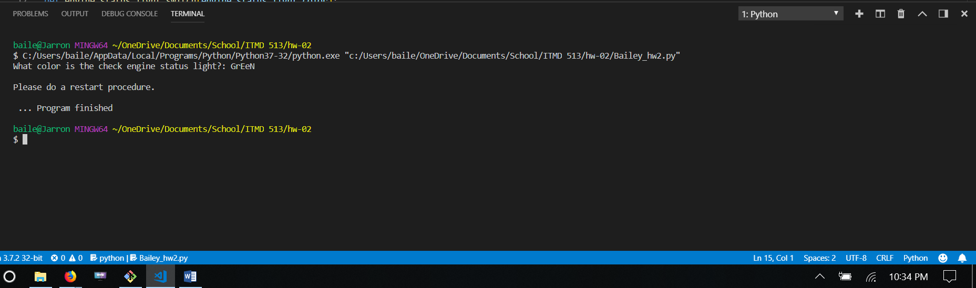

**Output for engine light = Amber**

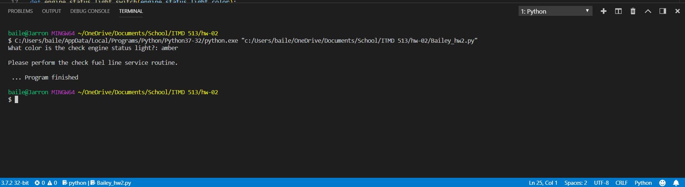

**Output for engine light = Red | Meter = <50 | Pressure = Normal**

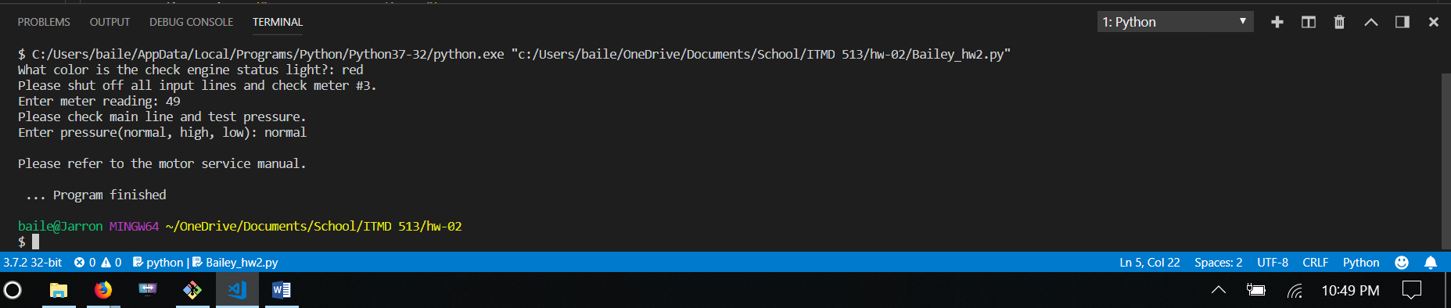

**Output for engine light = Red | Meter = <50 | Pressure = High or Low**

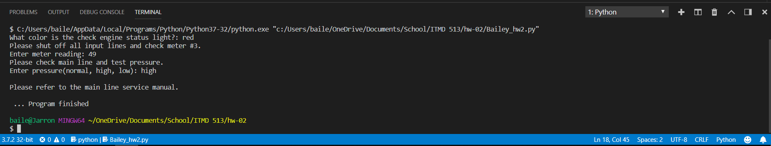

**Output for engine light = Red | Meter is >=50 | Pressure = Normal**



**Output for engine light = Red | Meter is >=50 | Pressure = High or Low**

